**AERONAUTICAL MAP**   
  
**OF THE GROOM LAKE/AREA 51 REGION**   
**Credit to DesertSecrets.com**

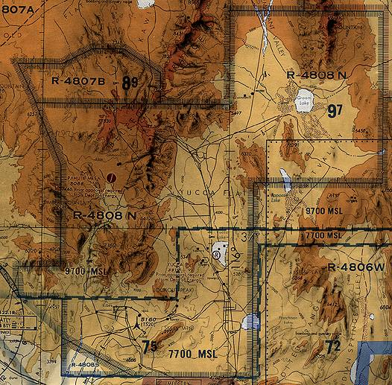

This is a portion of the 58th edition of the Las Vegas Sectional Aeronautical Chart from 11 September 1997. Sectional charts are distributed by NOAA. A newer edition has since been published; therefore, this chart is technically obsolete for use in navigation.

The Department of Energy is the controlling authority for the R-4808 airspace. Though this chart gives the airspace over Groom Lake the R-4808N designation, the actual designation of the airspace over Groom Lake is R-4808E.

The airspace over Groom Lake is continuously restricted to an "unlimited" ceiling, which presumably ends somewhere before low Earth orbit.